**CHAPTER 1: INTRODUCTION**

For an organization to run successfully and efficiently , it must have efficient workers and uses its resources very well, especially Human resources. So one of the important goals of an organization is to provide full knowledge about footwear. So there should be a proper recruiting process management system so that all the activities and selection procedures can be carried out effectively without losing transparency. An online Footwear system will be of great help in carrying out Footwear operations and with this very objective in mind, this Footwear Information and Sell System has been made.

In this web base Footwear system, we will manage all such activities like managing products and a variety of products, purchasing and selling footwear, and adding new footwear stock details and their status will save time, manpower, and the biggest advantage of being web-based. This web-based system will provide a better perspective for the enhancement of the organization regarding quality and transparency.

* 1. **Abstract :**

The Online Footwear system is a Java Project a web-based application that enables customers to order footwear online from this website. The project is built using Java, JSP, Servlets, and MySQL database technologies.

The system allows customers to register and log into their accounts, browse products, and place orders. The application provides a user-friendly interface that allows customers to select their preferred products, choose a variety of products, and customize their orders according to their preferences.

The system also provides an administrator dashboard that allows website owners to manage their products, orders, and customer details. The dashboard provides real-time analytics and reports on order volume and other performance indicators.

The project uses various technologies such as Java, JSP, Servlets, and MySQL, which makes it scalable and efficient. The use of these technologies also allows for easy maintenance and updates.

* 1. **Existing System :**

1. There are many players in the market of the footwear industry but there are very less options for dedicated footwear-related applications.

1. Applications like Flipkart, Amazon, Myntra, etc .are of some renowned names in this market but they have not dedicatedly used applications for searching for footwear.
2. This is a multi-product brand and they have a stake in supplying footwear from manufacturers and consumers.
3. Foot craft India, Bijnis, Finish line, etc are some dedicated systems and brands that focus on the footwear segment only.
4. The brands like Nike, puma, reebok, Adidas, etc also have a website that contributes to this segment.
   1. **Need for System :**
5. The systems that host multiple products often overlook the footwear segment and let cheap quality products host through its systems.
6. People often fall for the cheap prices of footwear and overlook their comfort.
7. They also overlook the scientific part of footwear design and only concentrate on the fancy part of it.
8. The dedicated system development on footwear will caress and identify comfort.
9. This is the need that will be addressed in this system**.**
   1. **Scope of System :**

The scope of the Online Footwear system Java Project is quite extensive and includes several key features:

1. **User Registration and Login:** Customers can register and login in too their accounts to access the system's features.
2. **footwear Management:** website owners can manage their products, add and remove categories, and update prices.
3. **Order Placement:** Customers can place orders, view their order history, and modify their orders.
4. **Order Fulfillment:** The system enables website owners to manage orders, accept or reject them, and track their status.
5. **Customer Management:** The system allows website owners to manage customer details, including order history and customer feedback.
6. **Analytics and Reporting:** The system provides real-time analytics and reports on order volume, bills, stock, and others.

The project's scope is not limited to these features, and other additional features such as ratings and reviews, loyalty programs, discounts, and promotions can be added to enhance the system's functionality.

In summary, the Online Footwear system Java Project is a comprehensive system that offers a range of products to provide a seamless experience for customers to order footwear and for website owners to manage their operations efficiently

* 1. **Operating Environment Hardware and Software :**

**Server-side requirement**

|  |  |
| --- | --- |
| **Software Requirement** | **Hardware Requirement** |
| Operating System:- Windows 10 or Above | Processor:- Intel i310th generation or above |
| Front End:- HTML, CSS  Back End:- JAVA | RAM:- 8 GB or above |
| Database:- MySQL | HDD:- 1TB or above |
| Web Browser:- Chrome, Mozilla Firefox |  |

**Client-side requirement**

|  |  |
| --- | --- |
| **Software Requirement** | **Hardware Requirement** |
| Operating System:- Windows 10 or Above | Processor:- Intel i3 10th generation or above |
| Web Browser:- Chrome, Mozilla, Firefox | RAM:- 4GB or above |
|  | HDD:- 500GB or above |

* 1. **Brief Description of Technology used :**

**HTML :**

HTML (Hypertext Markup Language) is the set of markup symbols or codes inserted in a file intended for display on a World Wide Web browser page. The markup tells the Web browser how to display a Web page's words and images for the user. Each markup code is referred to as an element (but many people also refer to it as a tag). Some elements come in pairs that indicate when some display effect is to begin and when it is to end.

**CASCADING STYLE SHEET (CSS) :**

Cascading Style Sheets (CSS) is a collection of rules we use to define and modify web pages. CSS is similar to styles in Word. CSS allows Web designers to have much more control over their pages’ look and layout. For instance, you could create a style that defines the body text to be Verdana, 10 points. Later on, you may easily change the body text to Times New Roman, 12 points by just changing the rule in the CSS. Instead of having to change the font on each page of your website, all you need to do is redefine the style on the style sheet, and it will instantly change on all of the pages to that the style sheet has been applied. With HTML styles, the font change would be applied to each instance of that font and have to be changed in each spot.

CSS can control the placement of text and objects on your pages as well as the look of those objects.

HTML information creates the objects (or gives objects meaning), but styles describe how the objects should appear. The HTML gives your page structure, while the CSS creates the “presentation”. An external CSS is just a text file with a . CSS extension. These files can be created with Dreamweaver, a CSS editor, or even Notepad.

The best practice is to design your web page on paper first so you know where you will want to use styles on your page. Then you can create the styles and apply them to your page.

**JavaScript :**

JavaScript is a programming language commonly used in web development. It was originally developed by Netscape as a means to add dynamic and interactive elements to websites. While JavaScript is influenced by Java, the syntax is more similar to C and is based on ECMAScript, a scripting language developed by Sun Microsystems.

JavaScript is a client-side scripting language, which means the source code is processed by the client's web browser rather than on the web server. This means JavaScript functions can run after a webpage has loaded without COMMUNICATING with the server. For example, a JavaScript function may check a web form before it is submitted to make sure all the required fields have been filled out. The JavaScript code can produce an error message before any information is transmitted to the server.

Like server-side scripting languages, such as PHP and ASP, JavaScript code can be inserted anywhere within the HTML of a webpage. However, only the output of server-side code is displayed in the HTML, while JavaScript code remains fully visible in the source of the webpage. It can also be referenced separately. JS file, which may also be viewed in a browser.

**JSP**

**Definition of JSP:**

Java Server Pages (JSP) is a technology used to develop interactive Web pages. JSP was developed by Sun Microsystems and is an improved version of Java servlets.

JSP may be developed in a simplified manner and has a wide range of applications. As with most server-based technologies, JSP separates business logic from the presentation layer.

JSPs are normal HTML pages with embedded Java code. To process a JSP file, developers need a JSP engine, which is connected to a Web server. The JSP page is then compiled into a servlet, which is handled by the servlet engine. This phase is known as translation. The servlet engine then loads the servlet class and executes it to create dynamic HTML, which is then sent to the browser.

**CHAPTER 2: PROPOSED SYSTEM**

**2.1 Feasibility Study :**

feasibility study of online footwear website This feasibility study will examine the viability of creating an online footwear website. The website will offer a wide selection of footwear styles and sizes, as well as provide helpful information and reviews on the products.

**1. Market Analysis** : The online footwear market is highly competitive, but there is still room for growth. The online footwear market has grown significantly over the past few years, with sales increasing by nearly 20% in the last year alone. The market is expected to continue to grow as more people become comfortable with buying footwear online

**2. Target Market** : The target market for the online footwear website will be adults between the ages of 18-35. These consumers are most likely to be tech-savvy and comfortable with online shopping. They are also likely to be interested in fashion and keeping up with the latest trends.

**3. Competitive Analysis** : The online footwear market is highly competitive. The major players in the market are Zappos, Foot Locker, and Amazon. These companies offer a wide selection of footwear styles and sizes, as well as helpful information and reviews on the products.

**4. Technology Requirements** : The website will need to be designed using HTML, CSS, and JSP. The website will also need to be optimized for mobile devices. The website will need to be able to process payments securely.

**5. Financial Feasibility** : Creating an online footwear website is a relatively low-cost venture. The website will require a minimal amount of startup capital to purchase the domain name, hosting, and design costs. The website will also need to be marketed to reach potential customers.

**6. Conclusion** : Creating an online footwear website is a feasible venture. The online footwear market is growing and there is room for new competitors. The website will need to be designed using the proper technology and marketed to reach the target audience. With proper planning and execution, the website could become a successful business.

**2.2 Objectives of the proposed system :**

People in large numbers are doing online shopping today, and it is not only because it is very

Convenient as customers can order the product from home in minimum time and several

variety of products to order from the website, and also it is easy to navigate for searching

regarding any particular product.

for footwear websites, their services have access to the worldwide market, which increases

the number of customers and enhances customer relationships also web services are a means for

small-scale companies to launch their products at the global level. The main objective of this

project is to develop a web that can provide online services to customers.

**CHAPTER 3: ANALYSIS AND DESIGN**

**3.1 Entity Relationship Diagram (ERD)** :

**3.2 Class diagram :**

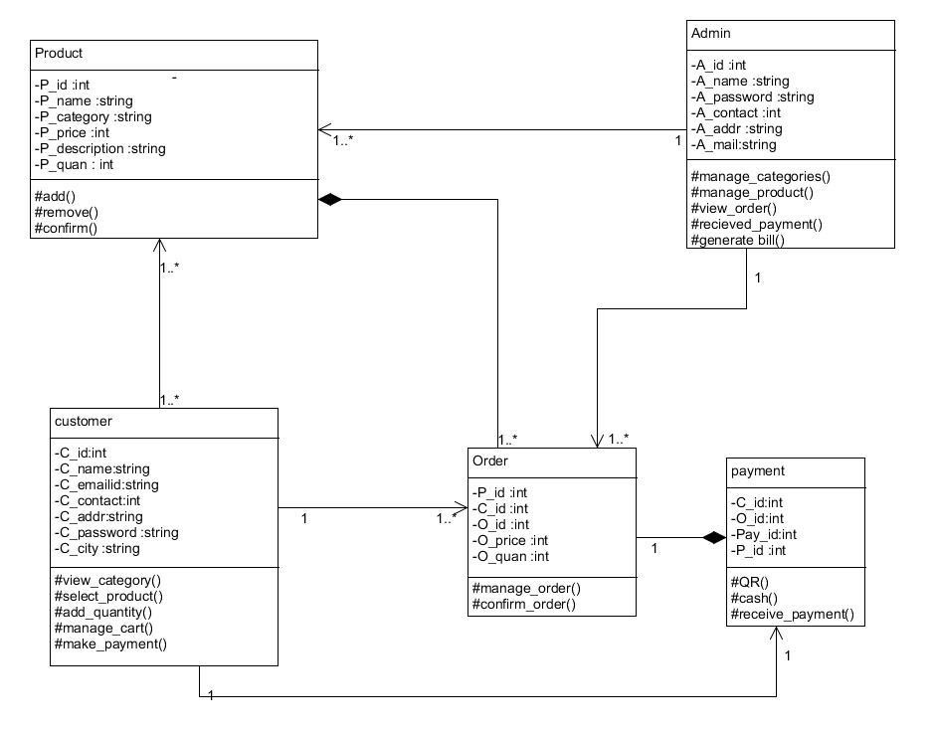

**3.3 Use Case Diagrams :**

**Admin use case**

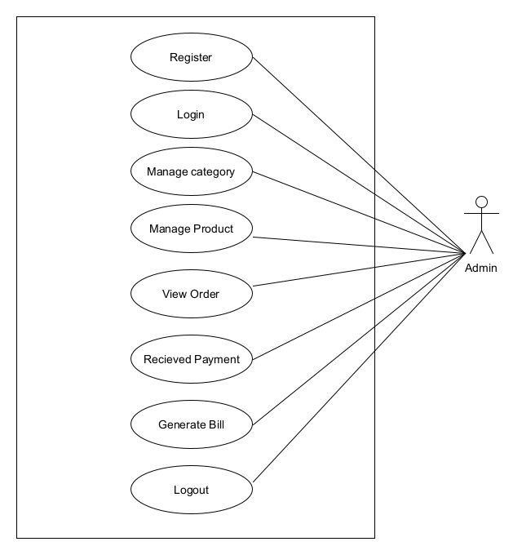

**Customer use case**

**Use case of system**

**Use case of product module**

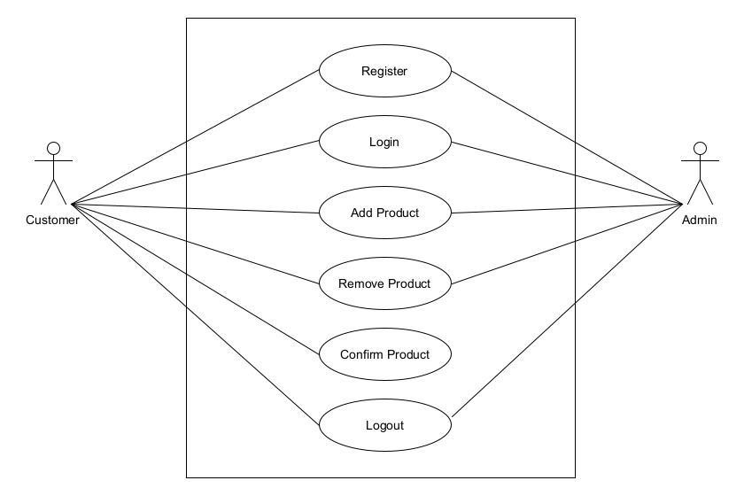

**Use case of order module**

**Use case of payment module**

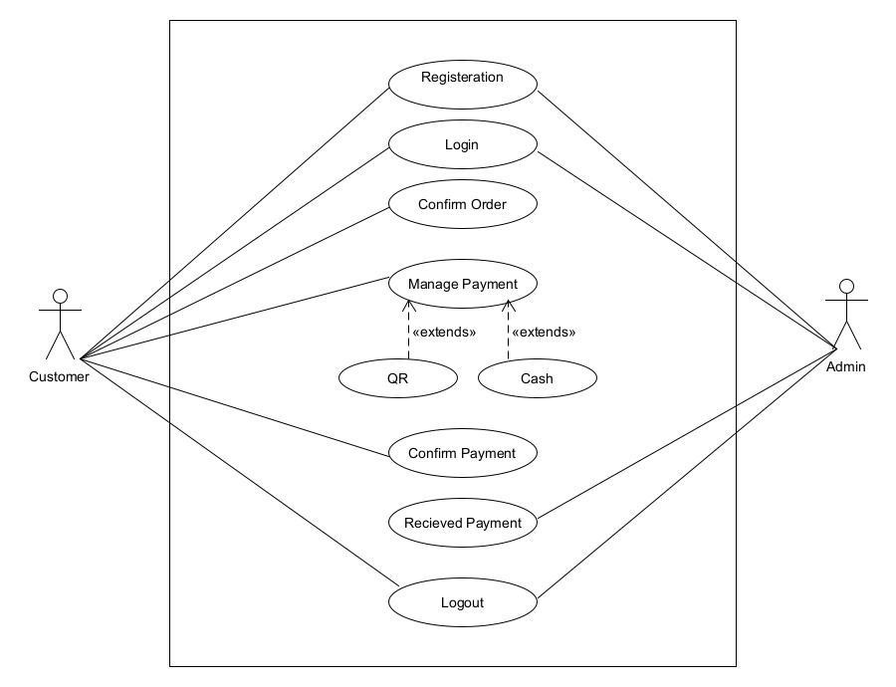

**3.4 Activity Diagram :**

**Activity diagram of admin**

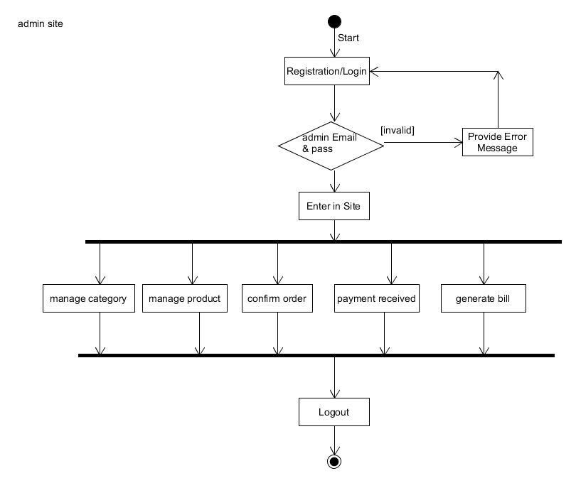

**Activity diagram of customer**

**Activity diagram of product module**

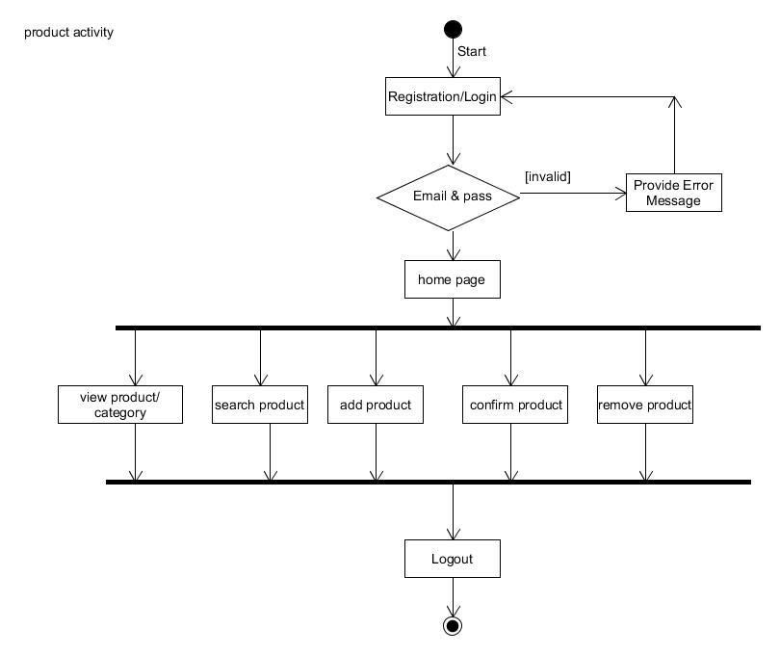

**Activity diagram of order module**

**Activity diagram of payment module**

**3.5 Sequence Diagram :**

**Seq. diagram of admin**

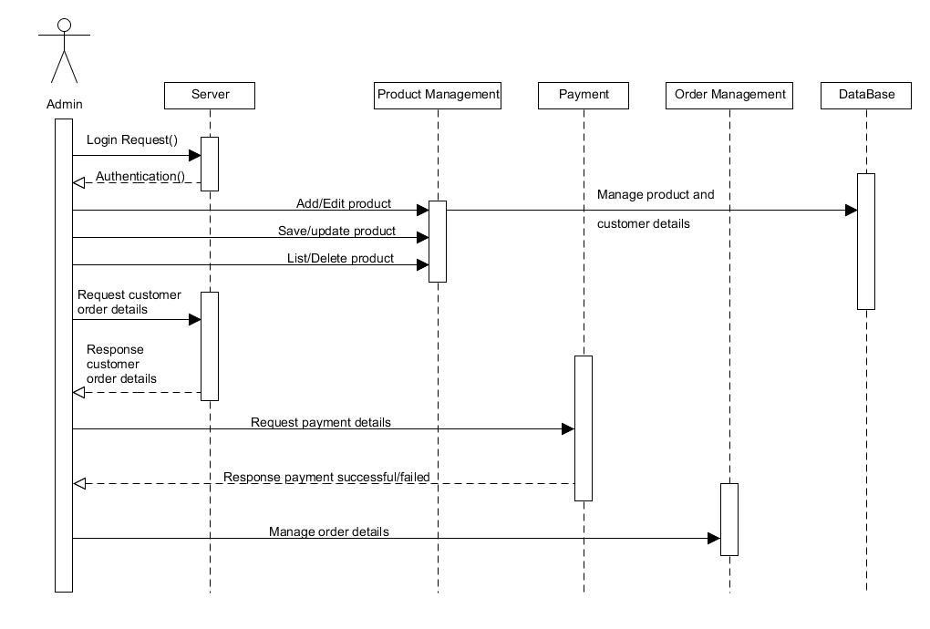

**Seq. diagram of customer**

**Seq. diagram of system**

**Seq. diagram of product**

**Seq. diagram of order and payment**

**3.6 component diagram :**

**3.7 Modules :**

1. **Customer Module**

**Register Module**

Customers can register by filling in the details to a get login ID and password.

**Login Module**

In this module customers and user can login into the project, by entering their emaild and password. If they don’t have an email and password they can go sign-up up page and can create account.

**Forget password Module**

If the user forgets the password then by forgetting the password module they can reset the password.

1. **Product Module**

This module starts when a user visits the product description page. A user can view various details of the product including name, category, price, and availability.

1. **Admin module**

The admin will be able to keep track of the product inventory and stocks.

The admin will have full access to the website.

1. **Ordering Module**

  The Ordering module is where users can order the goods and can select thier quantity accordingly.

**Add to Cart**

The user can add items to the cart because they can select a variety of goods at a time.

**Remove to cart**

The user can remove the product from the cart.

1. **Payment module**

In this module there are two methods to pay bill. customer can pay their amount by cash on delivery and online method .

**3.8 Table Design :**

**TABLE admin**

|  |  |  |  |  |  |
| --- | --- | --- | --- | --- | --- |
| Sr.no | Field name | Field size | Data type | Description | constraint |
| 1 | A_id | 10 | int | admin id | Primary key |
| 2 | A_name | 30 | varchar | admin name | Not null |
| 3 | A_pass | 12 | varchar | admin password | Not null |
| 4 | A_contact | 14 | int | admin contact | Not null |
| 5 | A_addr | 50 | varchar | admin address | Not null |
| 6 | A_email | 30 | varchar | admin email | Not null |

**TABLE customer**

|  |  |  |  |  |  |
| --- | --- | --- | --- | --- | --- |
| Sr.no | Field name | Field size | Data type | Description | constraint |
| 1 | C_id | 10 | int | Customer id | Primary key |
| 2 | C_emailid | 30 | varchar | Customer email | Default null |
| 3 | C_password | 12 | varchar | Customer password | Not null |
| 4 | C_name | 30 | varchar | Customer name | Default null |
| 5 | C_contact | 14 | int | customer contact | Default null |
| 6 | C_addr | 50 | varchar | Address of customer | Default null |
| 7 | C_city | 10 | varchar | City of customer | Default null |

**TABLE order**

|  |  |  |  |  |  |
| --- | --- | --- | --- | --- | --- |
| Sr.no | Field name | Field size | Data type | Description | constraint |
| 1 | O_id | 10 | int | Order id | Primary key |
| 2 | P_id | 10 | int | Product id | Foreign key |
| 3 | C_id | 10 | int | Customer id | Foreign key |
| 4 | O_quan | 10 | int | Quantity of product | Default null |
| 5 | O_price | 10 | float | Price of product | Default null |
| 6 | O_name | 10 | varchar | Name of product | Default null |

**TABLE product**

|  |  |  |  |  |  |
| --- | --- | --- | --- | --- | --- |
| Sr.no | Field name | Field size | Data type | Description | constraint |
| 1 | P_id | 10 | int | Product id | Primary key |
| 2 | P_name | 20 | varchar | Product name | Not null |
| 2 | P_category | 30 | varchar | Category of product | Not null |
| 3 | P_price | 10 | float | Price of product | Not null |
| 4 | P_image | 100 | varbinary | Image of product | Not null |
| 5 | P_desc | 30 | varchar | Product description | Not null |
| 6 | P_quan | 10 | int | Product quantity | Not null |

**TABLE Payment**

|  |  |  |  |  |  |
| --- | --- | --- | --- | --- | --- |
| Sr.no | Field name | Field size | Data type | Description | constraint |
| 1 | Pay_id | 10 | int | Price of product | Primary key |
| 2 | C_id | 10 | int | customer id | Foreign key |
| 3 | P_id | 10 | int | Product id | Foreign key |
| 4 | O_id | 10 | int | Order id | Foreign key |

**3.9 Data Dictionary :**

|  |  |  |  |  |  |
| --- | --- | --- | --- | --- | --- |
| **Field name** | **Datatype** | **Size** | **Constraints** | **Description** | **Table Name** |
| a_id | int | 10 | Primary key | Represent admin Id | Admin |
| a_name | varchar | 30 | Not null | Represent admin full name | Admin |
| a_pass | varchar | 12 | Not null | Represent admin login password | Admin |
| a_contact | varchar | 14 | Not null | Represent admin phone no | Admin |
| a_addr | varchar | 50 | Not null | Represent admin address | Admin |
| a_emailid | varchar | 30 | Not null | Represent admin email id | Admin |
| c_id | int | 10 | Default null | Represent Customer id | Customer |
| c_password | varchar | 12 | Not null | Represent Customer login password | Customer |
| c_name | varchar | 30 | Default null | Represent Customer full name | Customer |
| c_addr | varchar | 50 | Default null | Represent Customer Address | Customer |
| c_city | varchar | 10 | Default null | Represent customer city | Customer |
| o_id | int | 10 | Primary key | Represent order id | order, payment |
| p_id | int | 10 | Primary key | Represent product id | order, payment, product |
| c_id | int | 10 | Primary key | Represent customer id | customer, payment, order |
| o_quan | int | 10 | Default null | Represent order quantity | order |
| o_price | float | 10 | Default null | Represent order id | Order |
| o_name | varchar | 10 | Default null | Represent order name | Order |
| p_id | int | 10 | Primary key | Represent product id | Product |
| p_name | varchar | 30 | Not null | Represent product name | product |
| p_category | varchar | 30 | Not null | Represent product category | Product |
| p_price | float | 10 | Not null | Represent product price | Product |
| p_image | varbinary | 100 | Not null | Represent product image | product |
| p_desc | varchar | 30 | Not null | Represent product description | product |
| p_quan | int | 10 | Not null | Represent product quantity | product |
| pay_id | int | 10 | Not null | Represent payment id | product |

**3.10 Sample Input and Output Screens :**

**Home page**

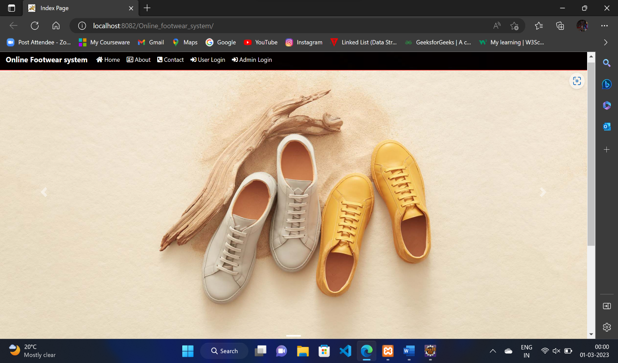

**Admin page**

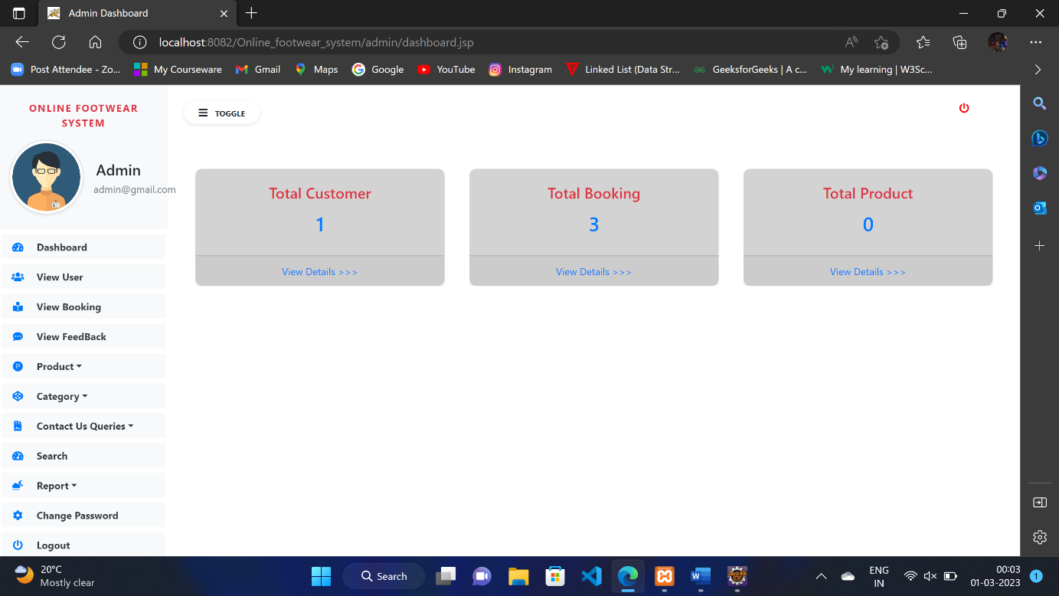

**Add product from the admin dashboard**

**Add a category from the admin dashboard**

**Search order id from the admin dashboard**

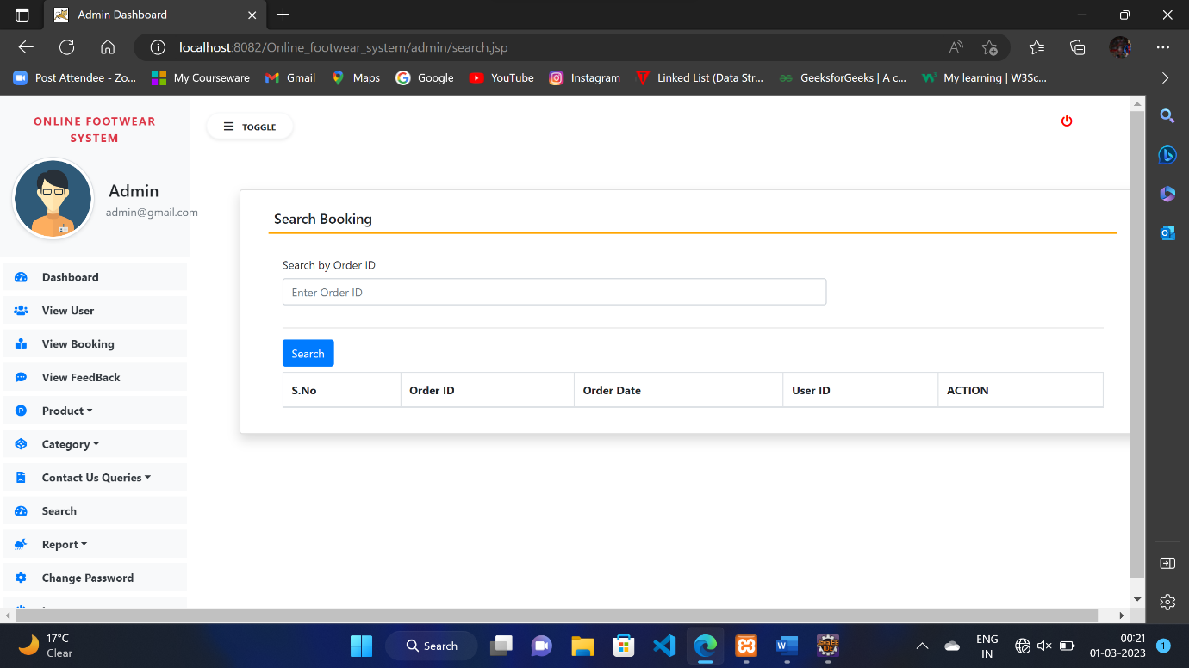

**View feedback from customer to admin**

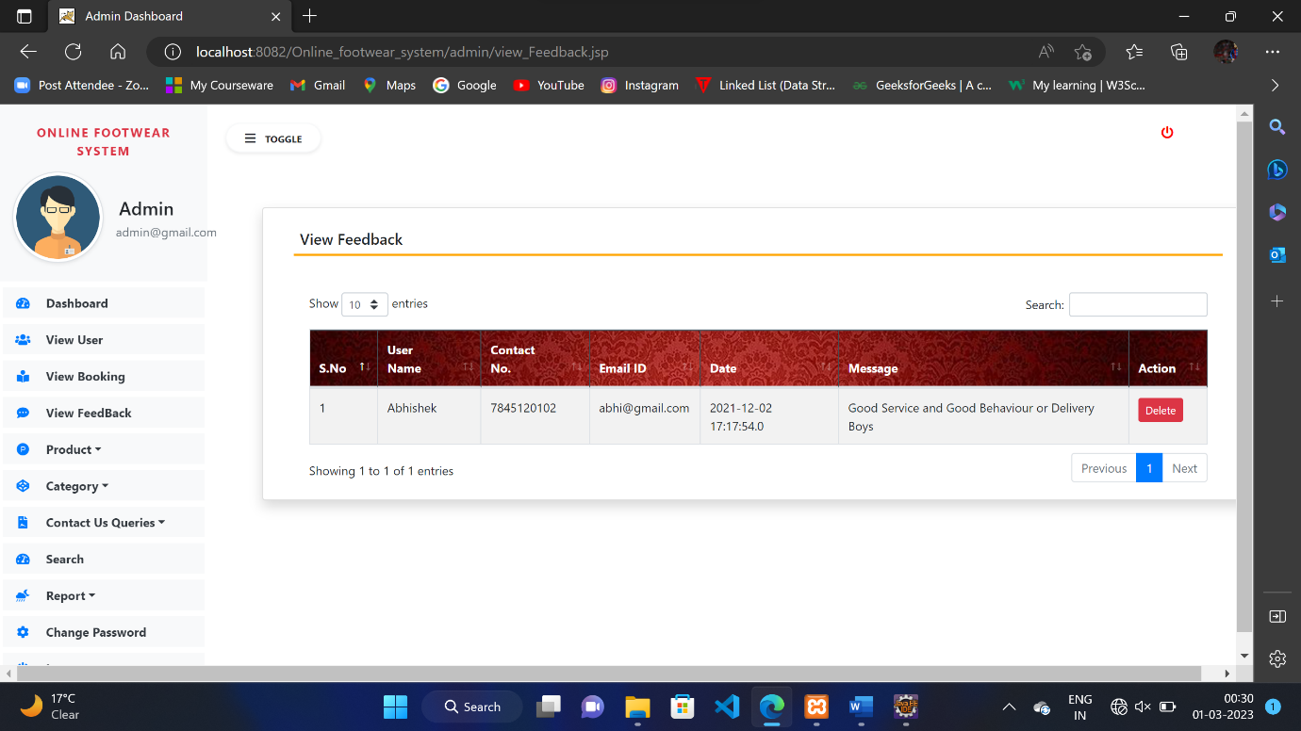

**Customer registration page**

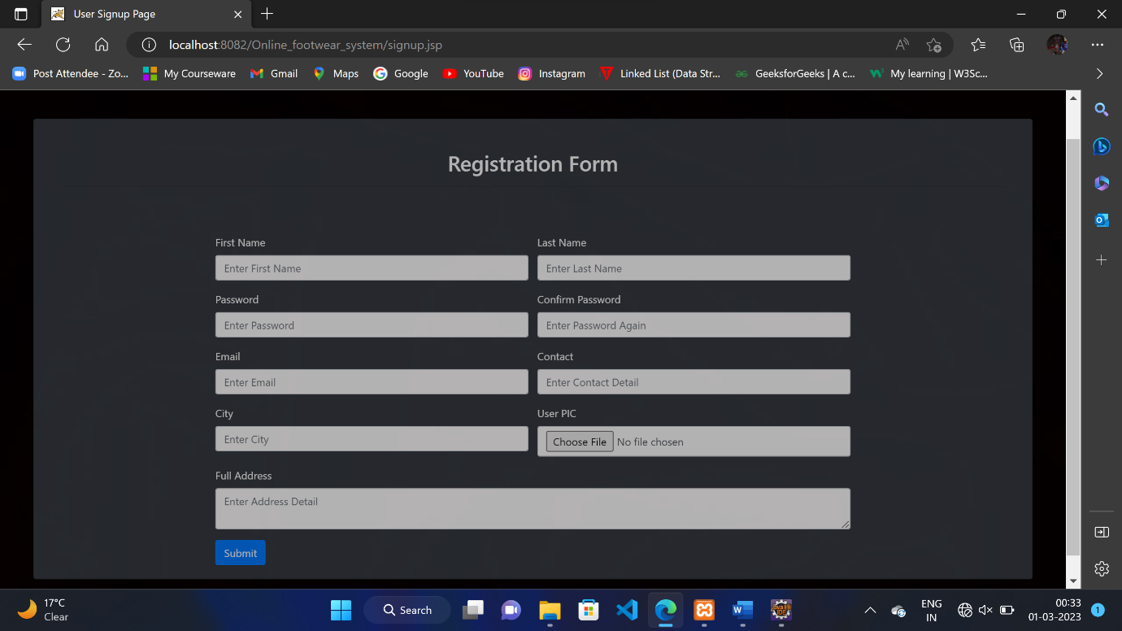

**Customer login page**

**View products for customers**

**Customer cart**

**Customer delivery address**

**Customer Bill Report:**

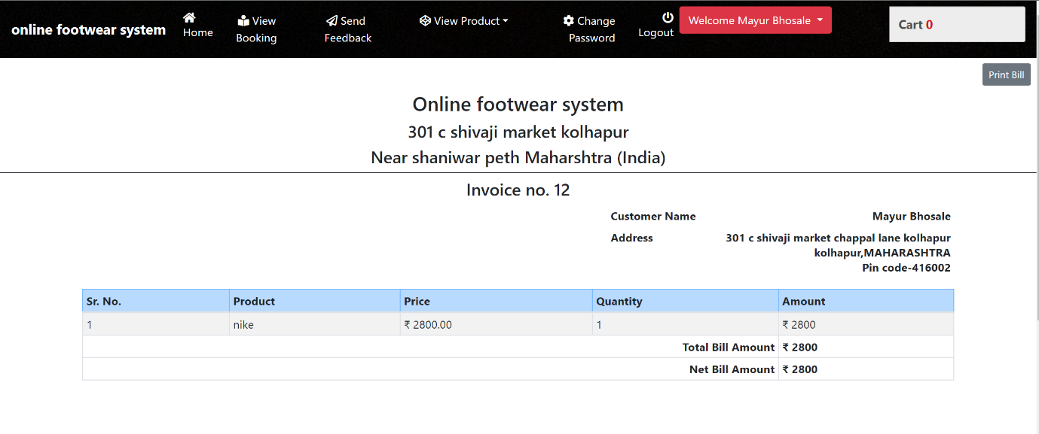

**Customer Bill Report:**

**Order Details Report:**

**Between Date Reports:**

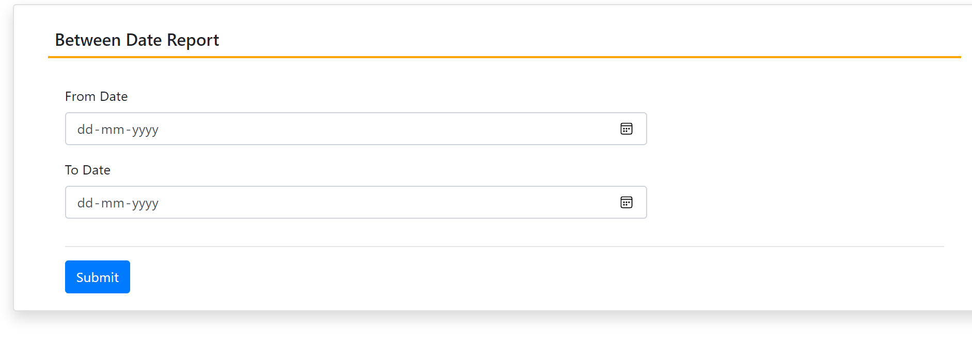

**Between Dates Reports:**

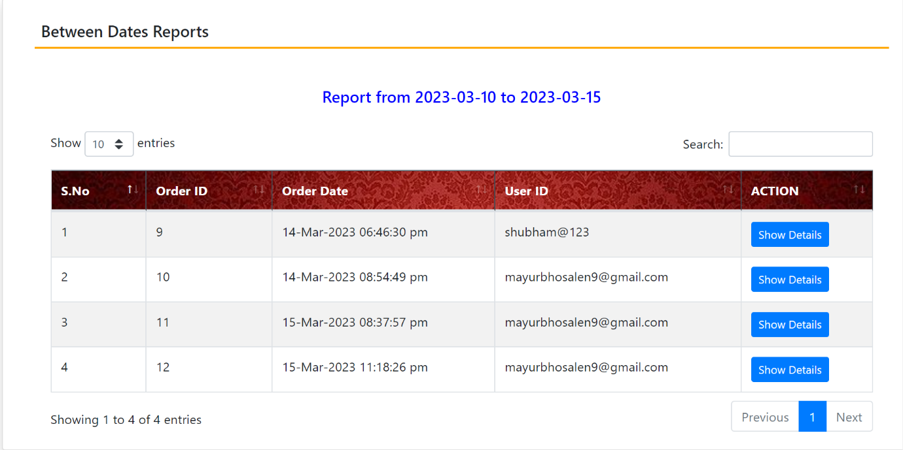

**CHAPTER 4: CODING Sample code :**

**HOME PAGE CODING**

**<%@page import="com.footwear.DbConnect"%>**

**<%@page import="java.sql.*"%>**

**<%@page import="java.util.List"%>**

**<%@ page language="java" contentType="text/html; charset=ISO-8859-1"**

**pageEncoding="ISO-8859-1"%>**

**<!DOCTYPE html>**

**<html>**

**<head>**

**<meta charset="ISO-8859-1">**

**<title>Index Page</title>**

**<%@include file="component/allCss.jsp"%>**

**<%@include file="component/navbar.jsp"%>**

**<link href="css/style.css" rel="stylesheet" type="text/css" media="all"/>**

**<link href="css/bootstrap.min.css" rel="stylesheet" type="text/css"/>**

**<link href="css/menu.css" rel="stylesheet" type="text/css" media="all"/>**

**<script src="js/jquery.min.js"></script>**

**<script src="js/script.js" type="text/javascript"></script>**

**<script src="js/move-top.js" type="text/javascript"></script>**

**<script type="text/javascript" src="js/easing.js"></script>**

**</head>**

**<body>**

**<div id="demo" class="carousel slide" data-ride="carousel">**

**<!-- Indicators -->**

**<ul class="carousel-indicators">**

**<li data-target="#demo" data-slide-to="0" class="active"></li>**

**<li data-target="#demo" data-slide-to="1"></li>**

**<li data-target="#demo" data-slide-to="2"></li>**

**<li data-target="#demo" data-slide-to="3"></li>**

**<li data-target="#demo" data-slide-to="4"></li>**

**<li data-target="#demo" data-slide-to="5"></li>**

**</ul>**

**<!-- The slideshow -->**

**<div class="carousel-inner" style="width: 100%; height: 550px">**

**<div class="carousel-item active">**

**<img src="static/images/c1.jpg" alt="Los Angeles"**

**style="width: 100%; height: 550px">**

**</div>**

**<div class="carousel-item">**

**<img src="static/images/c2.jpg" alt="Chicago"**

**style="width: 100%; height: 550px">**

**</div>**

**<div class="carousel-item">**

**<img src="static/images/c3.jpg" alt="New York"**

**style="width: 100%; height: 550px">**

**</div>**

**<div class="carousel-item">**

**<img src="static/images/c4.jpg" alt="New York"**

**style="width: 100%; height: 550px">**

**</div>**

**<div class="carousel-item">**

**<img src="static/images/c5.jpg" alt="New York"**

**style="width: 100%; height: 550px">**

**</div>**

**<div class="carousel-item">**

**<img src="static/images/c6.jpg" alt="New York"**

**style="width: 100%; height: 550px">**

**</div>**

**</div>**

**</div>**

**<!-- Left and right controls -->**

**<a class="carousel-control-prev" href="#demo" data-slide="prev"> <span**

**class="carousel-control-prev-icon"></span>**

**</a>**

**<a class="carousel-control-next" href="#demo" data-slide="next"> <span**

**class="carousel-control-next-icon"></span>**

**</a>**

**</div>**

**<%String succMsg = (String) session.getAttribute("succMsg");**

**if (succMsg != null) {**

**%>**

**<script>**

**alert("Logout Successfully...");**

**window.location.assign("index.jsp");**

**</script>**

**<%session.removeAttribute("succMsg");**

**}**

**%>**

**<br>**

**<div class="container">**

**<center><div class="search_box">**

**<form action="SearchResult.jsp">**

**<input type="text" list="products" value="" name="spname" placeholder="Product to Search">**

**<input type="submit" value="SEARCH" style="height:100%">**

**</form>**

**</div></center>**

**<br>**

**<h2 class="text-danger mt-5">Features Product</h2>**

**<hr>**

**<div class="row mb-5">**

**<div class="main">**

**<div class="content">**

**<%**

**if (session.getAttribute("msg") != null) {**

**%>**

**<div class="row">**

**<div class="col-sm-5 mx-auto">**

**<div class="alert alert-success text-center p-1 my-1">**

**<strong><%= session.getAttribute("msg")%></strong>**

**</div>**

**</div>**

**</div>**

**<%**

**session.removeAttribute("msg");**

**}**

**%>**

**<div class="section group">**

**<%**

**try {**

**Connection con1 = DbConnect.Connect();**

**Statement st = con1.createStatement();**

**ResultSet rs = st.executeQuery("select * from products where featured='Yes'");**

**int i = 0;**

**while (rs.next()) {**

**i++;**

**%>**

**<div class="grid_1_of_4 images_1_of_4 overflow-hidden">**

**<a href="cart1.jsp?prodid=<%= rs.getInt("prodid")%>&qty=1">**

**<img height="200" width="200" src="images/<%= rs.getString("photo")%>" alt="" /></a>**

**<h2 class="p-2 border mt-1"><%= rs.getString("pname")%></h2>**

**<p class="p-0"><%= rs.getString("pcat")%></p>**

**<p class="p-1"><span class="strike">&#8377;<%= rs.getString("price")%></span>**

**<span class="price">&#8377;<%= rs.getString("disc_price")%></span></p>**

**<% if (!rs.getString("instock").equals("In Stock")) {%>**

**<div class="pos-absolute"**

**style="transform: rotate(-45deg);top:125px;left:-90px;width:420px">**

**<div class="alert alert-danger font-weight-bold p-2 ">**

**<%= rs.getString("instock")%>**

**</div>**

**</div>**

**<div class="button mr-0">**

**<a href="javascript:void(0)">Add to Cart</a>**

**</div>**

**<div class="button ml-0"><span><a href="javascript:void(0)" class="details">Details</a></span></div>**

**<% } else { %>**

**<div class="button mr-0">**

**<a href="Operation?prodid=<%= rs.getInt("prodid")%>&qty=1">Add to Cart</a>**

**</div>**

**<div class="button ml-0"><span><a href="cart1.jsp?prodid=<%= rs.getInt("prodid")%>" class="details">Details</a></span></div>**

**<% } %>**

**</div>**

**<%**

**}**

**} catch (Exception e) {**

**System.out.println(e);**

**}**

**%>**

**</div>**

**</div>**

**</div>**

**</div>**

**</div>**

**</body>**

**</html>**

**CHAPTER 5: LIMITATIONS OF THE SYSTEM :**

**1. Limited Range of Products**: A footwear website can only offer a limited range of products, which may not be able to meet the needs of customers who are looking for more specific or niche items.

**2. Limited Merchant Options**: A footwear website may not have access to the same merchant options as a physical store, which can limit the selection of products and prices available to customers.

**3. Shipping and Returns**: Shipping costs and return policies may be more restrictive on a website than with a physical store, which can be a hindrance for customers who want to purchase items.

**4. Security Concerns**: There may be security concerns with purchasing items online, which can lead to hesitation from customers who are concerned about their personal information being shared or stolen.

**CHAPTER 6: PROPOSED ENHANCEMENTS :**

There are several proposed enhancements that can be made to online footwear system to address some of its limitations and improve the customer experience, including:

**1** **Improved user experience**: Online footwear system platforms can be enhanced by improving the user experience, including the latest products, simplified designs, and offer for products.

**2 Personalization**: Online footwear system platforms can be designed to personalize the experience for customers by offering a variety of products based on customer preferences and ordering history.

**3 Live chat support**: Live chat support can be added to online footwear system platforms to enable customers to ask questions and receive support in real time.

**4 Real-time tracking**: Real-time tracking of orders can be added to online footwear system platforms to provide customers with accurate information about the status of their orders

**5 Quality assurance**: Quality assurance measures can be implemented to ensure that footwear quality and delivery standards are maintained, and quality will check before going to customers.

**6 Loyalty programs**: Loyalty programs can be added to online food footwear system platforms to incentivize repeat business and build customer loyalty.

**7 Integration with social media**: Online footwear system platforms can be integrated with social media to allow customers to share their experiences and provide feedback to website.

**CHAPTER 7: CONCLUSION :**

The success of a footwear website depends on its ability to meet customer needs. From the quality of the shoes to the ease of use of the website, everything needs to be taken into consideration. With the right strategies, a footwear website can be successful by providing an enjoyable experience to customers and by offering quality products. Additionally, website owners should also focus on marketing and advertising efforts to ensure that their website is seen by their target audience. With the right strategies and attention to detail, a footwear website can be a successful venture.

**CHAPTER 8: BIBLIOGRAPHY :**

**REFERENCE BOOKS**

1. Java Web Fundamentals by Kevin Jones
2. Spring Framework 5: Beginner to Guru
3. JSP, Servlets and JDBC for Beginners: Build a Database App  
   Head First Servlet and JSP
4. Servlet & JSP: A Tutorial, Second Edition
5. Murach's Java Servlets and JSP, 3rd Edition

**WEB REFERENCES**

1. <http://www.roseindia.net/jsp/jsp.htm>
2. <http://java.sun.com/javaee/5/docs/tutorial/doc/bnafd.html>
3. [http://www.javaworld.com](http://www.javaworld.com/)
4. <http://java.sun.com/products/servlet/articles/tutorial/>
5. <http://www.coreservlets.com/>